Tier 1: Alcohol Harm Prevention Grants Application Drafting Tool

Things to know before you get started:
- Keep your formatting simple – formatting will not transfer to the VicHealth Stakeholder Portal (e.g. font, line spacing, dot points will not transfer)
- There are 6 sections of the application form in the VicHealth Stakeholder Portal and this is reflected in this Drafting Tool, where each section is numbered to correspond with the online application form.
  - As you progress through the online application form, you can tell which section you’re up to by looking at the top of the page in the progress bar. The progress bar will change from blue to green, to signify when you have completed a section.
  - Use the Navigation Pane in Word to skip between sections in this document easily (go to ‘View’ tab, and tick ‘Navigation Pane’ to enable this in Word)
- Once you are ready to submit, copy and paste your drafted responses into the corresponding boxes in the online application form, via the VicHealth Stakeholder Portal. Applications must be submitted through the online application form in order to be considered, before the closing date.

Step 1 of 6

Step 1: Introduction
The Introduction screen will remind you of key requirements and the closing date and time of 12pm on Monday 14th November 2022. No response is required for this section.

Step 2 of 6

Step 2: Eligibility and Compliance Check
Complete the eligibility and compliance check for your organisation. Questions are listed in bold.
The organisation responsible for your project must meet the eligibility requirements of this grant. Complete the following check list. The organisation responsible for your project:

is a Victorian Local Government Entity
⃝ Yes

⃝ No

If you are not a Victorian Local Government Entity, you are not eligible for this funding round.

is applying with a project that will focus on alcohol harm prevention for Victorians?
⃝ Yes

⃝ No

has satisfactorily fulfilled previous and/or current VicHealth funding requirements, if applicable?
⃝ Yes

⃝ No

⃝ N/A

Yes = The Organisation has received funding from VicHealth in the past and has satisfactorily fulfilled all funding requirements
No = The Organisation has received funding from VicHealth in the past but has not satisfactorily fulfilled all funding requirements
N/A = The Organisation has not received VicHealth funding in the past

holds all necessary insurances, including Worksafe certificate of currency and public liability insurance of $2 million per event for the proposed project, or, if insurance is not currently held, commits to purchasing all necessary insurances before commencing the project. Further information about required insurances is provided in the funding guidelines.
⃝ Yes

⃝ No

The application will describe a project that clearly meets all of the required project criteria and will respond to the criteria as outlined in the funding guidelines?
⃝ Yes

⃝ No

Tobacco industry relationship declaration

Do you or the organisation applying for funding have any current, planned or past five (5) year relationships with a tobacco company, the Australian Tobacco Research Foundation, or other tobacco industry funded bodies? For more information please click here.
⃝ Yes

⃝ No

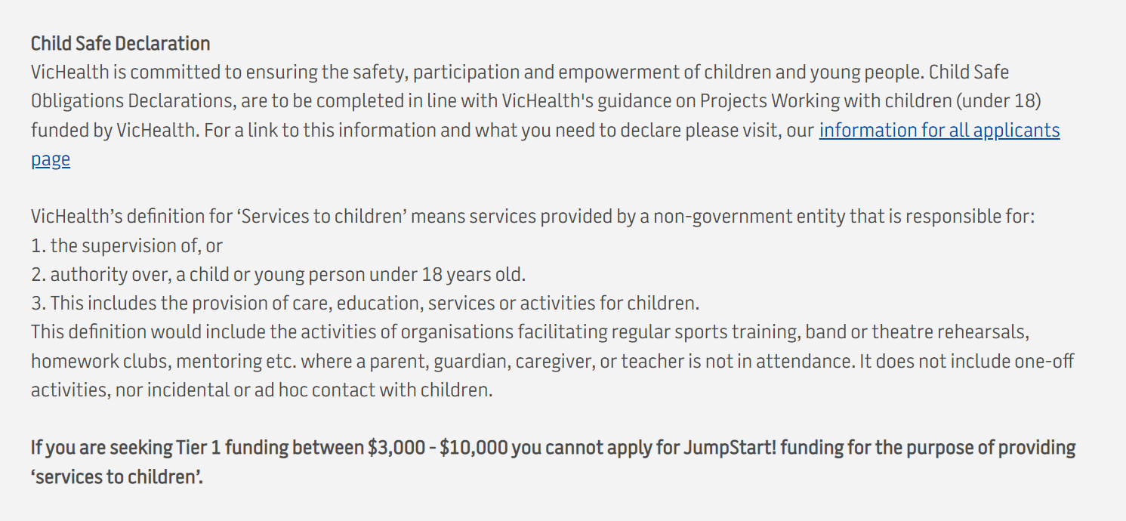

Based on the information above and reading VicHealth’s definition of delivering Services to Children, can you confirm if your project delivers services to children?
⃝ Yes

⃝ No
If No,
Please detail how your proposal does not provide services to children.
Click here to enter text (max 200 words).

If Yes
Please confirm your organisation has or will implement prior to the contract starting, child safe protocols and working with children checks for all relevant staff?
⃝ Yes

⃝ No

If No, based on your selection, it looks like you do not meet the eligibility requirements for this grant round. Please refer to the funding guidelines for more information.
If Yes,
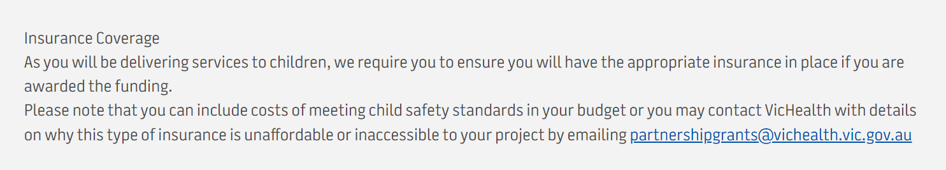

Is child abuse coverage at a minimum insured amount of $5 million per claim ( or $10 million in the case of insurance for a monetary aggregated amount) unaffordable or inaccessible for your organisation? Please attach evidence of quote if possible

Tip: You can include any associated costs incurred by your organisation to meet VicHealth’s Child Safe requirements within your project budget. In the event that your organisation cannot access or afford stand-alone insurance that provides indemnity for liability for child abuse, you can seek a public liability insurance policy that contains a sub-limit for sexual abuse.

Please attach insurance certificate or quote

Step 3 of 6

Step 3: Organisation and Contact Details
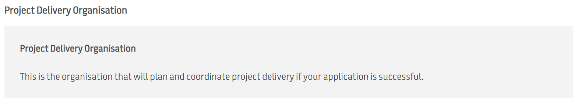

Council name:
Click here to enter text.

Australian Business Number
Click here to enter text.

Address
Click here to enter text.

Email
Click here to enter text.

Website
Click here to enter text.

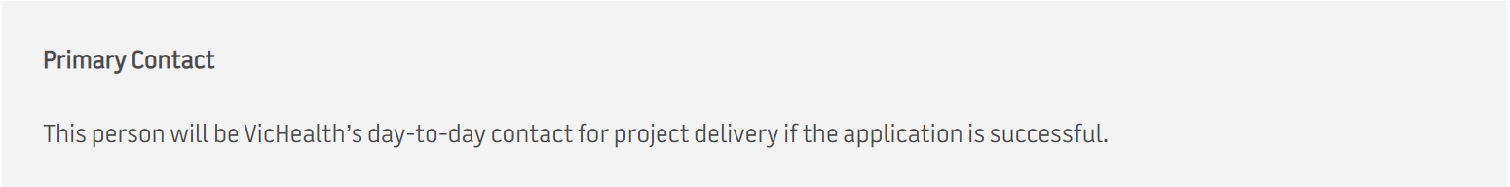
Salutation:
Select an option

First Name

Last Name

Position Title

Email
If you are the Primary Contact, enter the same email address you are using to access the VicHealth Portal.

Phone

Mobile:
Or

Landline:
Is the Primary Contact authorised to sign the Letter of Offer if your application is successful?
- Yes
- No
Tip: Agreements are typically signed by a CEO or head of department. If you selected yes for the above question, proceed to ‘Bank details for payment to successful applicants’.

Authorised Representative Contact information
Authorised Representative Contact: This is the person signing the funding agreement if your application is successful. Note: The funding agreement will be sent to the name and email address provided here.

Salutation
Select an option

First name
Click here to enter text.

Last name
Click here to enter text.

Position title
Click here to enter text.

Email
Click here to enter text.

Bank details
Bank details for payment to successful applicants
If your application is successful, we will start getting the payment ready for processing as soon as possible. Providing bank details here will help prevent processing delays and ensure funds are paid in time for projects to start.
VicHealth may get in touch to validate the details provided in this section before processing payment.

Name on account
Click here to enter text.

Account number
Please enter a 9-digit account number. If your bank account number is less than 9 digits, add extra 0s at the start (E.g. 001234567)

BSB
Click here to enter BSB.
Please provide an email address for remittance advice.
Click here to enter text.

Step 4 of 6

Step 4: About your project
This is where you get to tell us about how you will use the funding from VicHealth to address alcohol harm prevention in your local government area.

Which tier of funding are you applying for?
☐ Tier 1 - $10,000
☐ Tier 2 – up to $40,000
Why has your council prioritised alcohol as a focus?
Click here to enter text (max 100 words).

Tip: Please keep this simple. Typical wording might be: We know [THIS] about [THIS GROUP OF PEOPLE]
Example answer: We know that we have high rates of alcohol use in our local government area among young people.

Who will lead the work to develop your council’s community alcohol profile and action plan?
Click here to enter text (max 80 words).

Tip: You may not have an existing staff member allocated to this work. Please indicate in your response if you plan to hire a new staff member for this work.

Are you committed to developing an action plan for alcohol harm prevention for your local government area?
☐ Yes
☐ No

Step 5 of 6

Step 5: Funding Information
Will the project receive financial or in-kind contributions from other sources?
⃝ Yes

⃝ No

If yes, please provide further details:
Click here to enter text (max 80 words).

Step 6 of 6

Step 6: Review
In this section of the Stakeholder Portal, all information you have entered in the online form will be listed for your review. You can edit sections of the application form if you notice any errors and need to make changes by clicking on the pencil icon. If you want to save as a draft, click ‘save & resume later’ – just don’t forget to go back and submit before the closing date.
Once you’re ready to submit, scroll down and select ‘Submit’ at the bottom of the page to send your application to VicHealth. You will receive an automated confirmation email to confirm your submission. To view a PDF copy of your application after submitting, go to ‘My Applications’ and make sure you select ‘Submitted Applications’ from the drop down menu to view and print your application submission.
Applications must be completed and submitted via this Portal by 12pm on Monday 14th November 2022. Applications with incorrect or incomplete information about your organisation (ie. ABN) will automatically be deemed ineligible and will not be assessed. Please review your application carefully.
In fairness to all applicants, we are unable to accept any late or incomplete submissions or provide individual feedback on funding applications.

Acceptance Statement
• I have read the funding guidelines
• The information provided in this application is true and complete to the best of my knowledge
• VicHealth, on receiving this information, may refuse this application if it becomes evident that information provided is incomplete or false
• I approve the information provided
• At the conclusion of the funding round VicHealth will publish names of successful organisations and basic details of projects funded
• I agree to participate in evaluation and capacity building activities if requested by VicHealth

Privacy Statement
- Any information provided will be collected, managed and securely stored in accordance with the principles in the Victorian Privacy and Data Protection Act 2014 and VicHealth’s Privacy Policy. For further information on VicHealth’s Privacy Policy and approach, please see our website https://www.vichealth.vic.gov.au/search/funding-partner-privacy-policy for further information.
Important!
Once you click Submit you will not be able to edit this application. Please ensure you have reviewed all the information. You may wish to save and resume later or access a ‘print’ copy from the buttons at the top of the page. We do however encourage early applications so if you are ready, please submit before 12pm on Monday 14th November 2022.
If ready to submit, complete the checkbox: I accept

End of application form.

