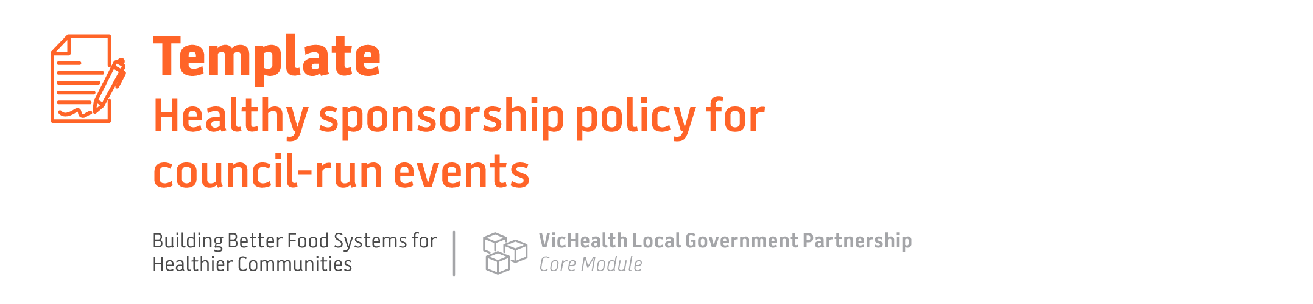

Policy objective
This policy aims to reduce the negative health and social impacts of unhealthy food and alcohol marketing to children and young people by not accepting sponsorships from unhealthy food and alcohol companies for council-run events.

Policy rationale
Council has a responsibility to provide for the health and wellbeing of its municipal community. Children and young people in our community deserve to grow up in an environment that supports their healthy growth and development and protects them from marketing of harmful products.

Children and young people are targets of marketing because of their own spending ability, their influence on parent spending, and because it fosters their lifelong brand loyalty²⁹.

Alcohol and unhealthy food brands seek sponsorship arrangements with community events where children and young people socialise, play, learn and create. This allows brands to promote harmful products to children and young people and increase product sales. And it works – research shows that marketing unhealthy food to children results in them preferring, buying more and eating more unhealthy food³⁰.

Similarly, exposure to alcohol marketing in teenagers is linked to an earlier onset of drinking for non-drinkers and increased drinking among those already drinking³¹.

This policy will reduce children and young people’s exposure to harmful products such as unhealthy food and alcohol, and contribute to protecting their health, safety and wellbeing. Furthermore, this policy aligns with the objectives outlined in the [Municipal Public Health and Wellbeing Plan/Council Plan] to support the health and wellbeing of our community including [list relevant objectives here, e.g. reduced obesity rates, promote healthy eating, reduced harm from alcohol, improved mental wellbeing, increased community safety].

Policy scope
This policy applies to unhealthy food and alcohol brand/company sponsorship (harmful sponsorship) of [specify types of events, for example, it may apply to all council-run events (including festivals, exhibitions, markets, music concerts) or only those events that are targeted primarily towards families, young people or children (may not include certain exhibitions or music concerts targeting those aged over 18 years)]. It does not include vendor retail relationships e.g. sale of food or alcohol at events where the vendor could advertise at point-of-sale (immediate service area) only.

Sponsorship is where companies support an event financially in exchange for brand exposure and promotion to attendees.

[Choose from broad or limited definition below or devise your own]

[Example of broad definition]
Council will assess the potential harm of all food and beverage industries seeking to sponsor council events using [insert description of your risk or principles-based approach to decision-making outlined in the ‘sponsor’ approval process section of the module].

In the case of alcohol, all producers are considered harmful sponsorship, e.g. brands shown on alcohol products, brewers, wineries, alcohol industry-funded foundations (Drinkwise), retailers (bottle shops) and on-premise providers (pubs, clubs).

[Example of limited definition]
Harmful sponsorship is defined as marketing activities by food, beverage and alcohol industries associated with the most harm and whose sole or predominate activity is the sale of alcohol or unhealthy food and drink.
This includes: [include from list or determine own]
- Alcohol producers (brands that produce alcohol products), alcohol industry-funded foundations (Drinkwise) and retailers (bottle shops). This would not include on-premise providers (pubs, clubs) or broader retailers who also sell alcohol (supermarket chains).
- All types of confectionery (including lollies and chocolate), processed food brands (cereals) and sugar-sweetened drink (including soft drinks, sports drinks, fruit drinks with less than 99% fruit, cordials and energy drinks) brands and fast food/chain food businesses.⁴
- This does not local businesses (such as a pizza shop).

Policy application
[Outline your council’s administrative process for assessing and approving sponsors, including the key decision-makers]

[If council is using a limited definition of harmful sponsorship in the policy scope]
Where potential sponsors meet the definition of a harmful sponsor (as defined in the policy scope), Council will not enter into a sponsorship arrangement with them.

[If council is using a broad definition of harmful sponsorship in the policy scope]
Where potential sponsors meet the definition of harmful sponsorship, the Council’s risk assessment is applied and Council will not enter into a sponsorship arrangement with a high-risk sponsor.
[Outline if the are other types of sponsorships that council will proactively seek, which may include a focus on healthy, local, ethical or other business types]

