1. **Challenge background and aims**

Active April is a State initiative that aims to get more people active during the month of April. It aligns with the Recreation and Wellbeing Team Goal;

*‘To enhance community health and wellbeing by facilitating an increase in physical activity participation and social connection’*

Officers are therefore keen to support Active April in any way possible and with the following key aims in mind;

* Facilitate additional exercise by Boroondara staff
* Help promote sporting clubs within Boroondara
* Facilitate additional exercise by the local community

1. **Challenge outline**

Outline of Rec and Wellbeing ideas;

* Active April walking challenge including lunch time walks.
* Ask all other departments to encourage people to sign up - they send info out to their networks
* Encourage clubs to participate in Active April via email to club contacts

The walking challenge began on Saturday 1 April.

‘Week 1’ ran from 1 April to the next Sunday and then the remaining weeks began each Monday until the last Sunday in April.

The dates for 2017 were;

**Week 1 -** April 1st - 9th April

**Week 2 -** April 10th - 16th April

**Week 3 -** April 17th - 23rd April

**Week 4 -** April 24th - 30th April.

To try and assist teams in increasing their number of steps, Recreation and Wellbeing also led a number of 3-4km lunchtime walks throughout April (2 per week).

Prizes were offered as per the table below.

|  |  |  |
| --- | --- | --- |
| **Achievement** | **Prize** | **Number required** |
| Random weekly prizes for most improved performance across all teams. | Week 1. Wrist Bands  Week 2. Nike - Drinks Bottles  Week 3. Rebel Voucher  Week 4. Drink Bottles | 40 |
| Most team steps each week. | Fruit and Veg Tray | 4 |
| Overall challenge winners (greatest distance). | $25.00 Half hour massage | 5 |

1. **Challenge setup**

There are a number of actions that were completed to run the challenge, as highlighted in the table below;

|  |  |  |  |
| --- | --- | --- | --- |
| **Action number** | **Action - Walking Challenge** | **Completion date** | **Notes** |
| 1 | Confirm with HR that can run walking challenge | Feb |  |
| 2 | Confirm challenge budget | Feb | Confirmed $900 |
| 3 | Setup share point for teams to record their steps. | Feb |  |
| 4 | Liaise with comms re News Flush promotion | Feb |  |
| 5 | Liaise with comms to get BAZ promotional article completed. Include info walking challenge and groups. Get up on 9/3 with a reminder on 29/3 (approx.) | Feb |  |
| 6 | Create posters to be distributed around Council | March | Distribute to staff areas by R&W team |
| 7 | Draft personal email to be sent out to healthy habits people, H&W group and other contacts. Draft once BAZ article completed | Mar | R&W staff to send to personal staff contacts |
| 8 | Draft ‘all staff’ email to be sent promoting Active April but also promoting the walking challenge/groups | Mar | To be sent by DCD |
| 9 | Confirm team led walk days and determine who will lead walks | Mar |  |
| 10 | Look at potential distances for prizes/link distances to prizes. | Mar |  |
| 11 | Purchase pedometers as required | Mar |  |
| 12 | Confirm prizes and order - fruit baskets, massage vouchers. | Mar |  |
| 13 | Send email out to Healthy Habits participants promoting the challenge/walks | Mar |  |
| 14 | Draft email to be sent out weekly updating on challenge progress | Mar |  |
| 15 | Send email out to entrants prior to challenge starting to remind them of how the challenge works etc. | Mar | Draft in file for review |
| 16 | Update register for team walks and print | Mar | Blank registers provided for people to sign, in line with the Risk Assessment |
| 17 | Create email distribution list | Mar | Distribution list of everyone on the challenge |
| 18 | Monitor challenge and arrange for prize distribution + send out weekly updates | Apr | Send out update (in line with action 14) |
| 19 | Design and send out survey to participants | May | Send out survey to participants to seek feedback |
| 20 | Complete review of challenge - update summary doc | June | Compile report and feedback from survey sent to participants. |

Share point was set up for all staff participating in the challenge to log their own steps either daily or weekly. Throughout the challenge, the team captains were asked follow up with all team members’ to ask them to log their steps, thus allowing the Recreation and Wellbeing staff to arrange prizes. At the start of each week a member of the Recreation and Wellbeing team sent out an email updating on the challenge, as detailed in Action 18 in table 2.

*\*Note - We allowed teams to have slightly more or fewer than 5 members per team. When sending out weekly updates and figuring out how far teams had walked, we averaged everyone to 5 members to keep things equal.*

1. **Challenge marketing**

At the moment the challenge is for internal staff only, therefore the challenge was promoted via the following mediums:

* BAZ
* Lunch meeting to promote
* Email to all staff
* Email to personal networks from the Recreation and Wellbeing team
* Email to staff who participated in *‘Healthy Habits’*
* Word of mouth during staff meetings etc.
* Newsflush
* Share point

1. **Challenge budget**

The initial budget was confirmed to be $900.

|  |  |
| --- | --- |
| **Item** | **Cost** |
| Marketing | $0 |
| Pedometers x 40 | $120.00 |
| Rebel Sport Vouchers x 10 | $200.00 |
| Rebel Sport Nike Drink Bottles x 10 | $152.90 |
| Brita Filtered Drink Bottles x 10 | $159.50 |
| Fruit Boxes x 4 | $130.10 |
| Massage Vouchers x 5 | $150.00 |
| **Total Expenditure** | **$912.50** |

1. **Challenge results and evaluation**

The challenge was well supported, with the following results;

***Total participants:*** 152

***Total steps walked:*** 42,570,795

***Total distance covered:* 42,571 Km**

***Final location (whole group):*** Whole group went around in the world in steps. We completed the lap and started on our second lap just passing New Zealand!!

***Top team distance:*** 2,434,873 (steps)

|  |  |  |
| --- | --- | --- |
|  |  |  |

The below maps demonstrate the final location of the individual teams as well as the entire group

*Final location map (whole group)*

Team Boroondara set a challenge to complete a lap around in the world. We completed the lap and started on our second lap just passing New Zealand!! 152 participants walked 42,570,795 steps. See the world map below:

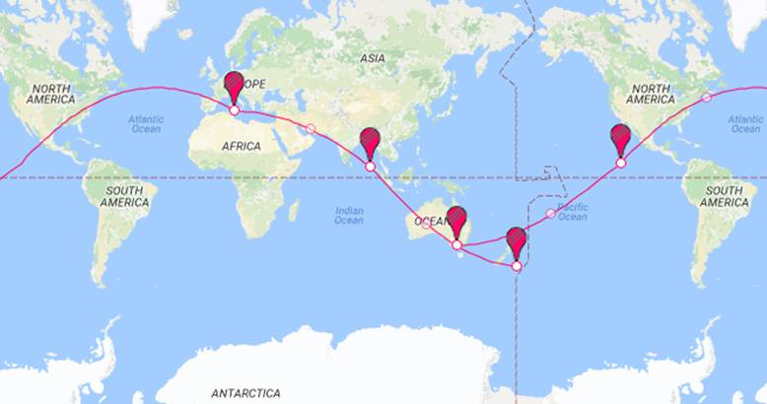

The pins represent week 4 (final week) of the challenge!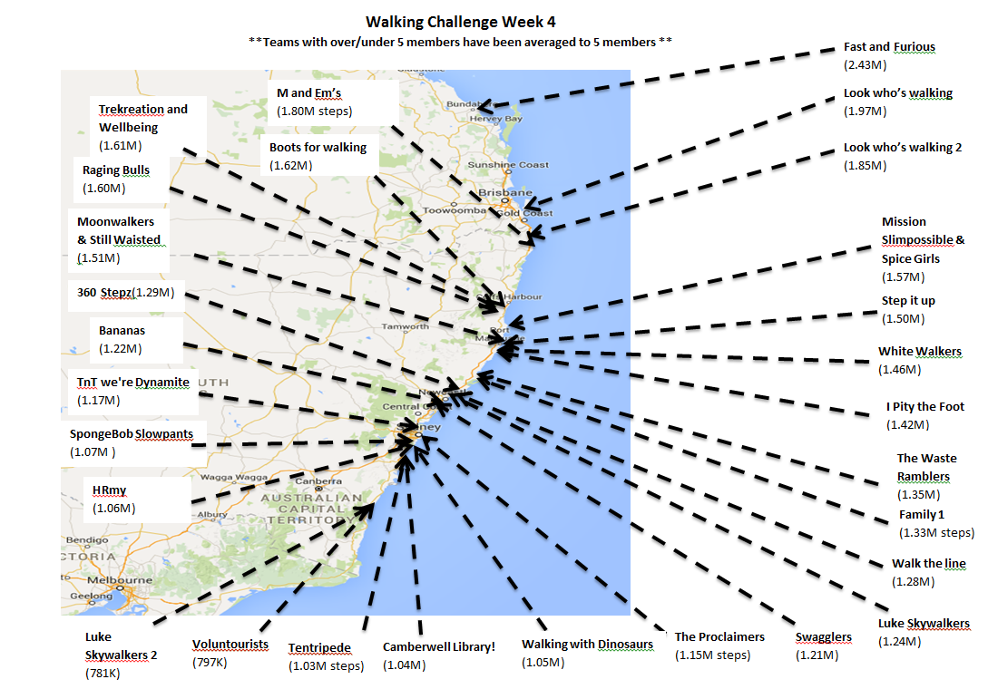

Following the completion of the challenge a survey was sent around to all participants. A total of 69 people completed this survey and a detailed summary of the results is included as **Attachment 1**. The main highlights were;

***Fun, social and team building***

* Keep up the good work! It's great to have initiatives running like this for staff morale. It provides opportunity for collaboration, fun and networking.
* Team bonding. Another way for the team members to collaborate
* It kept me motivated to be active and pushing me to do more.
* It was good to be able to work together with a team of co-workers.
* Having a reason to get out of the office and go for a walk during the day.
* Good way to improve fitness in a team environment
* It's an enjoyable team project, it encourages us to exercise & a bit of friendly rivalry never goes astray.
* Team effort and support. Motivated you more to get involved and improve.

***Health benefits***

* made me more aware to move and get up from the desk more often throughout the challenge
* It pushed me to do more than I would normally do, which is great for my health and the teams' success.
* Watching and reflecting on the daily variations in steps taken
* Motivation to change habits, also estimates for comparative exercise i.e. swimming
* Could healthy habits and walking challenge be combined as the health benefits overlap.

***Other key points***

* “Not be so close to the healthy habits challenge”?
* “get decent pedometers - scrap the prizes...there were so many prizes but if the pedometers don't work correctly then it’s a guessing game. i'd rather have a pedometer to keep using after challenge is over, but the $2 crap fell apart day 1. “
* “do not introduce other methods of exercise - base this on actual walking”
* “I think a lot of people got frustrated with the old pedometers and so dropped out/stopped recording their steps”.
* “Go longer than a month”.
* “Reliability of pedometers”.
* “Photos so we could see who the other teams were!”

**7.0 Recommendations**

From both the number of participants and survey results it is clear that there is support for running this challenge again in the future. There are a number of recommendations from both the survey results and other feedback received throughout the challenge:

* Feedback from survey results and anecdotal information received shows confusion over the link between the healthy habits challenge and the walking challenge. It is strongly recommended that the healthy habits challenge merge with the walking challenge.
* Increasing budget for more accurate pedometers or wrist bands.
* Promotion of more unstructured team driven walks. Feedback from staff was that organised walks were not popular; the challenge may look to promote more teams walking together.
* The launch (lunchtime) meeting to raise the profile of the event was popular and the recommendation is to keep this as part of the walking challenge structure moving forward.

**Proposed budget for next challenge:**

Based on 152 people participating;

|  |  |
| --- | --- |
| **Item** | **Cost** |
| Launch Lunch - 80 people approx | $PCD |
| Marketing | $0 |
| Massage vouchers - 5 @ $25ea | $150 |
|  |  |
| Fruit platters - 4 @ $30ea | $120 |
| Pedometers - 80 approx @ $25 | $3000 |
|  |  |
| Prizes - 40 @ $10 | $400 |
| **TOTAL** | **$3,670** |

The above budget would enable us to source a /reliable pedometer or preferably wristbands for staff that do not already have a reliable/comfortable device to accurately measure steps.

**Attachments**

1. Post challenge survey results