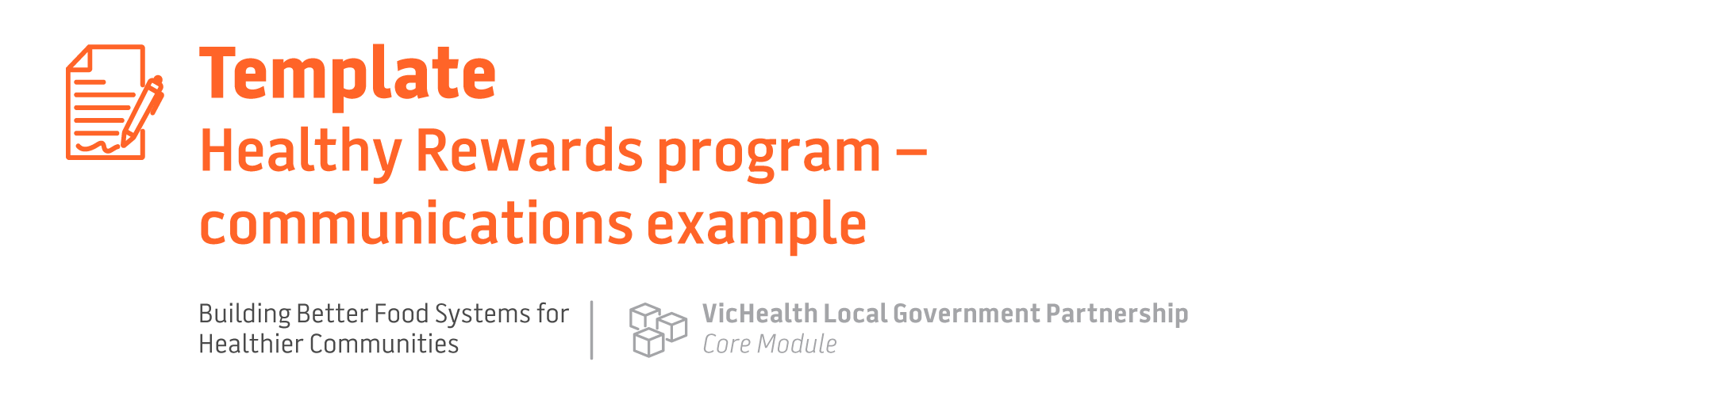

[Council] project halts junk food vouchers in kids’ [insert sector, e.g. sport and arts]

[Insert sectors e.g. junior clubs, youth theatre] in [local government area] can take part in the Healthy Rewards program and replace vouchers for fast food and takeaway with fun and active options for [insert arrangements, e.g. free or discounted access to a local pool or tennis court].

[Council] is launching a new Healthy Rewards program in a bid to phase out unhealthy food vouchers in kids’ [insert sector, e.g. sport and arts activities].

The Healthy Rewards program allows participating [insert sectors e.g. junior clubs, youth theatre] to replace vouchers for fast food and takeaway with healthy and fun activities, like [insert arrangements, e.g. free or discounted access to a local pool or tennis court].

[insert following paragraph if program covers sporting clubs] This much-needed program responds to VicHealth and Deakin University research, showing that 2 in 3 parents think kids’ sports rewards should be healthy. Among the 500 Victorian parents surveyed, half (51%) said their children had received a voucher from a large fast-food company at their sports club, and 42% had received one for a local fast-food outlet.

Rewarding children and young people with vouchers for fast food builds powerful brand associations at a young age. It draw families into their restaurants and encourages them to buy more products, making companies a lot of money at the expense of children’s health.

We all want children and young people to grow up [select all applicable: socialising, playing, learning and creating] in healthy environments. This is a fantastic opportunity for [Council] and [insert sectors e.g. junior clubs, youth theatre] to team up and protect children and young people from advertising, and put health and wellbeing of children and young people above junk food company profits.

[If applicable insert relevant quotes or case studies from parents, children, young people, participating organisations and/or leaders within Council]

How to get involved
If your organisation is interested in joining the Healthy Rewards program, please contact [insert name and details].

