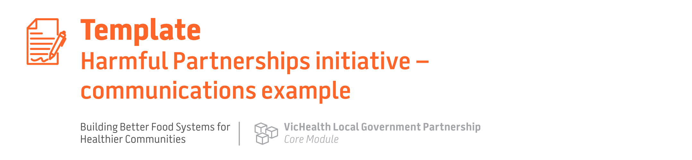

[3] things [insert sector, e.g. sporting clubs] can do to improve the health of your [community/members]

We all want children and young people in [name of area] community to grow up in an environment that supports their health and development and protects them from harmful products. However, alcohol and unhealthy food brands often seek sponsorships with [insert sector, e.g. sporting clubs] where children and young people [select all applicable: socialise, play, learn and create].

This allows brands to promote harmful products to children and young people and drive sales through proven marketing tactics such as vouchers, product giveaways and displaying logos on uniforms and equipment [or add/remove marketing tactics as applicable to your chosen sector]. And it works – research shows that marketing these products results in children and young people eating more unhealthy food and drinking more alcohol products. It also makes these harmful brands and products much more recognisable across the community.

What’s more, communities want their local events to be free from unhealthy food and alcohol sponsors. A 2020 study of Victorian parents of junior sport club members showed 63% prefer that sporting clubs are only affiliated with sponsorship that aligns with good health³² [or insert community polling data on attitudes towards unhealthy food and alcohol sponsorship if available]

Your [organisation/club/venue] can set a higher standard and show your [community/members] that you stand to protect their health, safety and wellbeing by limiting sponsorship arrangements with unhealthy food and alcohol brands. Below are 3 ways you can get started.

Top tips [remove those not applicable]
1. Swap to healthy rewards
Swap out participation or achievement rewards from harmful brands (e.g. unhealthy food and drink vouchers, alcohol prizes) for healthy rewards by joining our Healthy Rewards program. [provide detail of the program if you have actioned ‘The quick win: Implement a healthy rewards program’ under the ‘Using healthy rewards and sponsorships in community activities’ impact stream]
2. Consider healthier sponsors
Look for healthier sponsors next time your sponsorship arrangements are up for review and prioritise organisations and brands that do not profit from products that harm health and wellbeing, for example:
- health services, e.g. physiotherapy, dental services or allied health providers
- sport, fitness or recreation providers
- sport, homeware, furniture or clothing retailers
- local businesses such as real estate agents, accounting/legal firms, gardening supplies or trades
If you must consider alcohol and unhealthy food sponsors, choose local businesses.
Avoid those that pose a greater risk to health and wellbeing:
- nationally or state recognised brands
- advertised widely on mass media
- solely or predominantly associated with a harmful product.
3. Place boundaries on harmful sponsors
If unhealthy food and alcohol sponsors are already in place, think about how you can put some boundaries in place to reduce their harm, for example:
- not activating harmful brands during junior events
- acknowledging harmful brands verbally or by text-only, rather than displaying their logo or product.
Further information
To find out more, check out these resources: [include if applicable]
- Healthy Sports Reward program
- VicHealth’s position on healthy sport sponsorship
- [include links to any other relevant council resources you have developed, e.g. webpage]

