Tier 2: JumpStart! Application Drafting Tool

Things to know before you get started:
- Keep your formatting simple – formatting will not transfer to the VicHealth Stakeholder Portal (e.g. font, line spacing, dot points will not transfer)
- There are 6 sections of the application form in the VicHealth Stakeholder Portal and this is reflected in this Drafting Tool, where each section is numbered to correspond with the online application form.
  - As you progress through the online application form, you can tell which section you’re up to by looking at the top of the page in the progress bar. The progress bar will change from blue to green, to signify when you have completed a section.
  - Use the Navigation Pane in Word to skip between sections in this document easily (go to ‘View’ tab, and tick ‘Navigation Pane’ to enable this in Word)
- If your application involves an Auspice arrangement, review information in Section 3 of 6: Organisation and Contact Details
- Once you are ready to submit, copy and paste your drafted responses into the corresponding boxes in the online application form, via the VicHealth Stakeholder Portal. Applications must be submitted through the online application form in order to be considered, before the closing date.

Step 1 of 6

Step 1: Introduction
The Introduction screen will remind you of key requirements and the closing date and time of 11.59pm on Tuesday 20 September 2022. No response is required for this section.

Step 2 of 6

Step 2: Eligibility and Compliance Check
Complete the eligibility and compliance check for your organisation, or the auspice partner if applicable. Questions are listed in bold.
The organisation responsible for your project (you or your auspice partner, if applicable) must meet the eligibility requirements of this grant. Complete the following check list. The organisation responsible for your project:

has an active Australian Business Number (ABN) and a bank account for Electronic Funds Transfer of project funds?
⃝ Yes

⃝ No

holds one of the following legal structures: a) incorporated association b) company limited by guarantee, c) Victorian Local Government Entity d)organization established by Acts of Parliament e)Indigenous Corporations
⃝ Yes

⃝ No
is applying with a project that will deliver activities in Victoria, with a focus on health and wellbeing outcomes for Victorians? ⃝ Yes

⃝ No

has satisfactorily fulfilled previous and/or current VicHealth funding requirements, if applicable?
⃝ Yes

⃝ No

⃝ N/A
Yes = The Organisation has received funding from VicHealth in the past and has satisfactorily fulfilled all funding requirements
No = The Organisation has received funding from VicHealth in the past but has not satisfactorily fulfilled all funding requirements
N/A = The Organisation has not received VicHealth funding in the past

holds all necessary insurances, including Worksafe certificate of currency and public liability insurance of $2 million per event for the proposed project, or, if insurance is not currently held, commits to purchasing all necessary insurances before commencing the project. Further information about required insurances is provided in the funding guidelines.
⃝ Yes

⃝ No
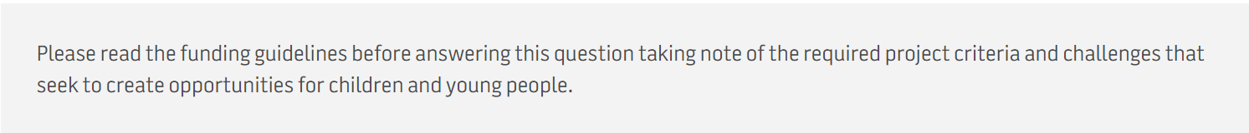

The application will describe a project that clearly meets all of the required project criteria and will respond to one or more of the challenges as outlined in the funding guidelines?
⃝ Yes

⃝ No

Tobacco industry relationship declaration

Do you or the organisation applying for funding have any current, planned or past five (5) year relationships with a tobacco company, the Australian Tobacco Research Foundation, or other tobacco industry funded bodies? For more information please click here.
⃝ Yes

⃝ No
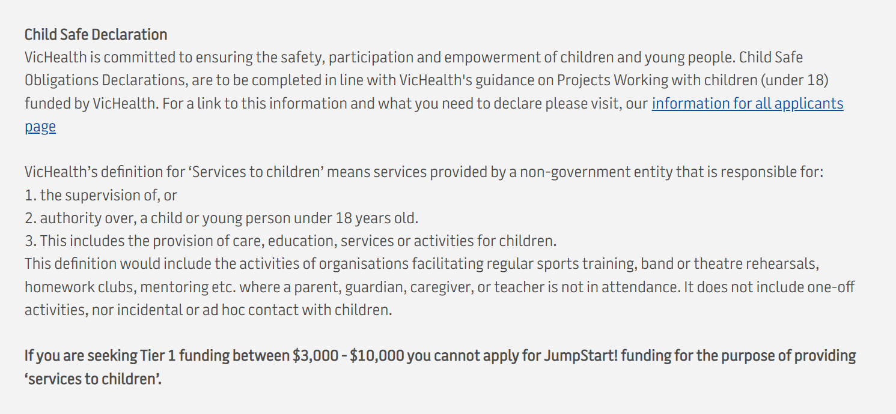
Based on the information above and reading VicHealth’s definition of delivering Services to Children, can you confirm if your project delivers services to children?
⃝ Yes

⃝ No
If No,
Please detail how your proposal does not provide services to children.
Click here to enter text (max 200 words).

If Yes
Please confirm your organisation has or will implement prior to the contract starting, child safe protocols and working with children checks for all relevant staff?
⃝ Yes

⃝ No
If No, based on your selection, it looks like you do not meet the eligibility requirements for this grant round. Please refer to the funding guidelines for more information.
If Yes,
Is child abuse coverage at a minimum insured amount of $5 million per claim ( or $10 million in the case of insurance for a monetary aggregated amount) unaffordable or inaccessible for your organisation? Please attach evidence of quote if possible
Tip: You can include any associated costs incurred by your organisation to meet VicHealth’s Child Safe requirements within your project budget. In the event that your organisation cannot access or afford stand-alone insurance that provides indemnity for liability for child abuse, you can seek a public liability insurance policy that contains a sub-limit for sexual abuse.

Please attach insurance certificate or quote:

Step 3 of 6

Step 3: Organisation and Contact Details
For applications involving an auspice organisation, we will collect details of both the Auspice Organisation and Project Delivery Organisation. For information about what it means to apply with an Auspice Organisation, please see the funding guidelines.

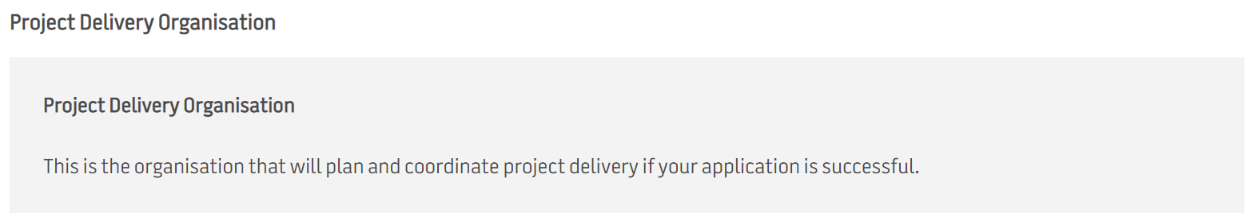

Project Delivery Organisation’s Trading Name?
Click here to enter text.

TIP: The name the Project Delivery Organisation is known by. E.g. VicHealth If unsure, check the Organisation’s entry on the Australian Business Register and look for Trading Name. This may be the same as the Legal Name

Australian Business Number
Click here to enter text.

Tip: You can run a search to confirm this 11-digit number using the Organisation’s name on the Australian Business Register .

Business Registration type
⃝ Company Limited by guarantee

⃝ Incorporated Association

⃝ Victorian local government entity

⃝ Indigenous Corporation

⃝ Established under Acts of Parliament

⃝ None of the above – application involves an eligible auspice organisation
If you select – “ Application involves an eligible auspice organisation”, you will be asked to fill in auspice organisation details below.

If Company Limited by Guarantee

Australian Company Number (CAN)
Click here to enter text.
Australian companies limited by guarantee should maintain active registration with the Australian Securities and Investment Commission. If you need help finding an ACN, visit ASIC Connect, and search by ‘Organisation Business names’.

If Incorporated Association
Incorporation Number
Click here to enter text.
Australian companies limited by guarantee should maintain active registration with the Australian Securities and Investment Commission. If you need help finding an ACN, visit ASIC Connect, and search by ‘Organisation Business names’.

If Indigenous Corporation
Incorporation Number
Click here to enter text.
Indigenous Corporations are registered with are registered with Office of the Registrar of Indigenous Corporations (ORIC). Search for an Indigenous Corporation Number (ICN) via the Office of the Registrar of Indigenous Corporations

If Established under Acts of Parliament
State the Act of Parliament under which the organisation is established e.g. Tobacco Act of 1987
Click here to enter text.

Upload relevant evidence on the application form on the portal
Organisation type
Select an option:
- Aboriginal and Torres Strait Islander Organisation
- Arts Organisation/Facility
- Government – Local
- Local/Community Sporting Club
- Health service (including community health services)
- Non-government organisation/community organisation – non-profit
- Sport – Elite sporting body
- Sport - Local/community sporting club
- Sport - National and State sporting organisation
- Sport - Regional Sports Assembly
- Sport - Sporting league/association
- Sport - State Sport and Recreation Bodies
Select from the drop down list, if you are unsure, select ‘Community Organisation’. This question will help us understand the type of organisation that will deliver the idea, and is not related to eligibility criteria.

Address
Click here to enter text.

Email
Click here to enter text.

Website
Click here to enter text.

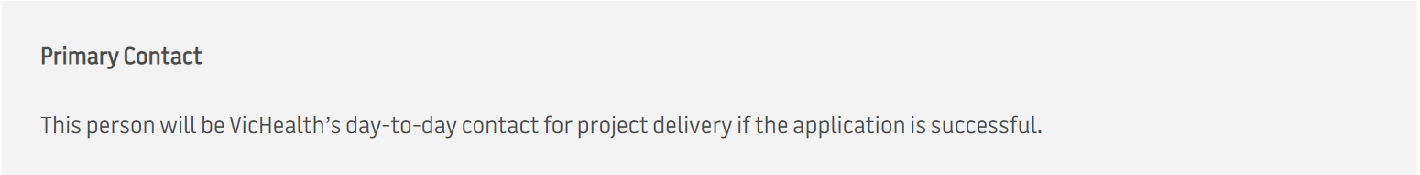

Salutation:
Select an option

First Name

Last Name

Position Title
If you are completing this form on behalf of the Project Delivery Organisation but do not work for them directly, please add your organisation’s name to the end of your position title.

Email
If you are the Primary Contact, enter the same email address you are using to access the VicHealth Portal.

Phone

Mobile :
Or

Landline:

Is the Primary Contact authorised to sign the Letter of Offer if your application is successful?
- Yes
- No
Tip: Agreements are typically signed by a CEO or head of department. If you selected yes,above question, proceed to ‘Bank details for payment to successful applicants’.

Bank details
Bank details for payment to successful applicants
If your application is successful, we will start getting the payment ready for processing as soon as possible. Providing bank details here will help prevent processing delays and ensure funds are paid in time for projects to start.
Note: If the application involves an auspice arrangement, VicHealth must make payment to the Auspice Organisation.
VicHealth may get in touch to validate the details provided in this section before processing payment.

Name on account
Click here to enter text.

Account number
Please enter a 9-digit account number. If your bank account number is less than 9 digits, add extra 0s at the start (E.g. 001234567)

BSB
Click here to enter BSB.
Please provide an email address for remittance advice.
Click here to enter text.

Authorised Representative Contact information
Authorised Representative Contact: This is the person signing the funding agreement if your application is successful. Note: The funding agreement will be sent to the name and email address provided here.

Salutation
(select from drop down list)
First name
Click here to enter text.

Last name
Click here to enter text.

Position title
Click here to enter text.

Email
Click here to enter text.

Auspice Details (if applicable)
Auspice Organisation
This organisation has agreed to partner with the Project Delivery Organisation and will accept legal and financial responsibility for the grant if your application is successful.

Auspice Organisation’s trading name
Click here to enter text.
Tip: The trading name is what the Auspice Organisation is known by. E.g. VicHealth. If unsure, check the Organisation’s entry on the Australian Business Register and look for Trading Name. This may be the same as the Legal Name.

Australian Business Number
Click here to enter text.
Tip: You can run a search to confirm this 11-digit number using the Organisation’s name on the Australian Business Register .

Business Registration type
⃝ Company Limited by guarantee

⃝ Incorporated Association

⃝ Victorian local government entity

⃝ Indigenous Corporation

⃝ Established under Acts of Parliament

If Company Limited by Guarantee

Australian Company Number (CAN)
Click here to enter text.
Australian companies limited by guarantee should maintain active registration with the Australian Securities and Investment Commission. If you need help finding an ACN, visit ASIC Connect, and search by ‘Organisation Business names’.

If Incorporated Association
Incorporation Number
Click here to enter text.
Australian companies limited by guarantee should maintain active registration with the Australian Securities and Investment Commission. If you need help finding an ACN, visit ASIC Connect, and search by ‘Organisation Business names’.

If Indigenous Corporation
Incorporation Number
Click here to enter text.
Indigenous Corporations are registered with are registered with Office of the Registrar of Indigenous Corporations (ORIC). Search for an Indigenous Corporation Number (ICN) via the Office of the Registrar of Indigenous Corporations

If Established under Acts of Parliament
State the Act of Parliament under which the organisation is established e.g. Tobacco Act of 1987
Click here to enter text.

Upload relevant evidence on the application form on the portal

Please provide details of your contact at the Auspice Organisation who has agreed to support this application.
Salutation
(select from drop down list)
First name
Click here to enter text.

Last name
Click here to enter text.

Position title
Click here to enter text.

Email
Click here to enter text.

Phone
⃝ Mobile
⃝ Landline

Address
Click here to enter text.

Please attach documentation confirming the auspice organisation has agreed to support this application, e.g. letter or email of support. Organisation and contact details on the documentation should match the auspice information provided above.

Step 4 of 6

Step 4: About your project

Project Summary
This is where you get to tell us about your idea or program, the priority group you plan to focus on and how VicHealth funds would enable your organisation to deliver on one or more of the JumpStart! challenges. Tip: Hover over the question mark icons for tips on how to answer each question as you move through the form.

Project title
Enter your project title below. You have up to 80 characters (including spaces) for your title, about 15 words. Consider your title, it should be easy to tell what the project is from the project title.
Click here to enter text (max 80 characters).
Please provide a summary description of your project in 1-2 sentences, your ‘elevator pitch’.
Click here to enter text (max 80 words).

Example Project Summary: (Org name) will deliver a weekly arts and storytelling program, run both indoors and outdoors, for children aged 1-6 years from culturally and linguistically
Tip: Please keep this simple. Typical wording might be: We [WILL DO THIS] for [THIS GROUP OF PEOPLE] so that [THIS THING WILL HAPPEN].
Example Project Summary: (Org name) will deliver a weekly arts and storytelling program, run both indoors and outdoors, for children aged 1-6 years from culturally and linguistically diverse backgrounds.

Which JumpStart! Challenge is the main focus area of your idea?
Please select one.
- Making sport environment more welcoming and inclusive to increase participation
- Introducing people to social and active recreation
- Connecting people through arts, cultural and play-based activities.
- Learning about their local food system and encourage connection through food

Tip: The challenges are described in the guidelines. Although some projects might address more than one challenge, please select the challenge that is the MAIN focus of the idea.

Project Rationale
Who will benefit from the project? You may select more than one.
☐ Pre-school age (0-4 years)
☐ Primary school age (5-11 years)
☐ Secondary school age (12-17 years)
☐ Young adults (up to the age of 25 years)
Tip: Project can target families/carers of children, but the people who will benefit must be young people aged 0-25 years.

What hardly reached group will your project target? You may select more than one.
☐ Aboriginal or Torres Strait Islander people
☐ LGBTQI+
☐ People living in a 2019/2020 bushfire affected area
☐ People living in rural or remote locations
☐ People living with a disability
☐ People on a low income
☐ People speaking a language other than English at home
☐ People who are unemployed
☐ Single parents
☐ Women and girls
☐ Other

Describe why the project is needed.
Click here to enter text (max 250 words).

Has your project been co-designed with children and young people (and/or their carers/families)? Describe your co-design approach.
Click here to enter text (max 250 words).

Describe how your project will deliver on the JumpStart! challenge you have selected. How will this benefit the target group/s
Click here to enter text (max 300 words).

How many young people within your target group will directly benefit from the project?
Click here to enter an estimated number.
Tips are not on website

Tip: Estimate the total number of young people that will directly benefit from your idea. This can be a simple number – e.g. ‘120’, or a short breakdown e.g. ’30 participants x 4 clubs = 120’

Why is your organisation is best placed to deliver the project?
Click here to enter text (max 300 words).

Tip: In responding to this question, outline that your organisation has the experience suited to the type of activity proposed and a demonstrated level of skill relative to the project's aims and complexity.

What will you do with the funding?
Click here to enter text (max 300 words).

Tip: This should include the project activities that will be delivered as a result of the funding (e.g. hiring staff; buying materials; promoting activity; running activity). This should be a high-level summary only so that the reader understands what you plan to do, and in what order, to deliver the project.

Please select from the list which activity/item your project is funding:
☐ Capacity building or training
☐ Delivery of a program (where more than one selection applies, for complex projects)
☐ Equipment, materials or other items (including equipment and uniforms)
☐ Project staffing or subcontracting
☐ Subsidised or free participation in programs, competitions or events
☐ Other

If you receive funding, where will funded activity take place?
Search for the address in the Stakeholder Portal.

Tip: If your address doesn't appear, click 'Enter your address manually' to enter your address.
Select one street address for the question above even if you plan to deliver across more than one location. Think of it this way: If your application is successful, and VicHealth or a local paper wishes to check out your work or come and take a photo, where would you invite them to meet you? If you are delivering online content or aren't yet sure of where your project will be delivered, please enter your organisation address.

In which Victorian local government area (or areas) will your project be delivered?
Choose from the drop down list of all LGAs

Step 5 of 6

Step 5: Funding Information

How much funding do you need from VicHealth?
Round to the nearest dollar and include access funding. Do not include GST in this amount. The minimum funding amount is $10,001 and the maximum funding amount is $50,000 for Tier 2 projects to be delivered over a maximum 12-month period.
Please enter your amount in dollars. Do not include cents.

Please enter the estimated start date of the project.

Tip: Delivery of funded projects is March 2023-March 2024

Please enter the estimated end date of the project.

Tip: Delivery of funded projects is March 2023-March 2024

Will the project receive financial or in-kind contributions from other sources?
⃝ Yes ( If yes, please include the financial and in-kind contributions from other sources in the budget template)
⃝ No

Attach your completed project budget below. Click on the information icon to download the budget template.

Upload or drag and drop your pre-completed budget in Excel or PDF format, then click ‘Done’.
Tip: Please refer to the grant guidelines for a description of access funding. Applicants must use the VicHealth budget template only, and submit it in Excel or PDF format. Click here to download the budget template.

Attach your completed workplan below. Click on the information icon to download a workplan template.
Note: This should include the project activities that will be delivered as a result of the funding (e.g. setting up steering group; hiring staff; buying materials; promoting activity; running activity). This should be a high-level summary only so that the reader understands what you plan to do, and in what order, to deliver the project.
Tip: Click here to download a workplan template.

Upload or drag and drop your pre-completed budget in Word or PDF format, then click ‘Done’.

Harmful Industries Relationship Declaration
Have you applied for more than $35,000?
If no, proceed to Step 6: Review by clicking on Next

⃝ Yes
⃝ No

If yes, Do you or the organisation applying for funding have any current , planned, or past 12 months relationships with the food, sugary drink, alcohol, or gambling industries?
If no, proceed to Step 6: Review by clicking on Next

⃝ Yes
⃝ No

If Yes, Harmful Industries Relationship Declaration
Harmful Industries Relationship Declarations are to be completed in line with VicHealth’s Harmful Industries Relationships Funding and Procurement Policy. Declarations do not affect your eligibility to apply. For this Policy and more information on the types of relationships you need to declare, visit VicHealth’s Harmful Industries Relationships Funding and Procurement Policy webpage.
Note: Declarations do not affect your eligibility to apply.

What relationships do you or the organisation have with the food, sugary drink, alcohol or gambling industries? Max. words 200.

Eg: Org commenced 3-year partnership with Company X in July 2022 (Max words 200).

Tip: In your answer, please detail the brand/company/organisation, the length of the relationship and when it occurred/is occurring/is planned. List all harmful industry relationships if you have more than one.
What was/is/will be the nature of the relationships, partnerships or sponsorship arrangements with the food, sugary drink, alcohol or gambling industries?

- Access to membership lists and data
- Board membership or other governance membership
- Campaign/project development or delivery
- Consultancy
- Marketing/brand activation
- Market or other research/evaluation
- Other
- Promotion or activation of the harmful brand/company
- Receipt of donations or in-kind benefits

Select all that apply and provide further detail if requested.

If you have additional information on your selections above that will help VicHealth to make an assessment, please include that here.

(Max words 200).

Please detail how harmful industry relationships will be risk-managed to ensure that VicHealth's statutory role to improve the health and wellbeing of Victorians is not undermined.
(Max words 250).

Tip: This could include, for example, separating project teams or not activating harmful industry brands alongside VicHealth’s brand. You are required to respond to this question even if the harmful industry relationship is not current?(i.e. past or future).
Note: If your application is shortlisted VicHealth has the right to negotiate your proposed management plan.

Step 6 of 6

Step 6: Review
In this section of the Stakeholder Portal, all information you have entered in the online form will be listed for your review. You can edit sections of the application form if you notice any errors and need to make changes by clicking on the pencil icon. If you want to save as a draft, click ‘save & resume later’ – just don’t forget to go back and submit before the closing date.
Once you’re ready to submit, scroll down and select ‘Submit’ at the bottom of the page to send your application to VicHealth. You will receive an automated confirmation email to confirm your submission. To view a PDF copy of your application after submitting, go to ‘My Applications’ and make sure you select ‘Submitted Applications’ from the drop down menu to view and print your application submission.
Applications must be completed and submitted via this Portal by 11.59pm on Tuesday 20th September 2022. Applications with incorrect or incomplete information about your organisation (ie. ABN) will automatically be deemed ineligible and will not be assessed. Please review your application carefully.

In fairness to all applicants, we are unable to accept any late or incomplete submissions or provide individual feedback on funding applications.

Acceptance Statement
• I have read the funding guidelines
• The information provided in this application is true and complete to the best of my knowledge
• VicHealth, on receiving this information, may refuse this application if it becomes evident that information provided is incomplete or false
• I approve the information provided
• At the conclusion of the funding round VicHealth will publish names of successful organisations and basic details of projects funded
• I agree to participate in evaluation and capacity building activities if requested by VicHealth

Privacy Statement
- Any information provided will be collected, managed and securely stored in accordance with the principles in the Victorian Privacy and Data Protection Act 2014 and VicHealth’s Privacy Policy. For further information on VicHealth’s Privacy Policy and approach, please see our website https://www.vichealth.vic.gov.au/search/funding-partner-privacy-policy for further information.
Important!
Once you click Submit you will not be able to edit this application. Please ensure you have reviewed all the information. You may wish to save and resume later, or access a ‘print’ copy from the buttons at the top of the page. We do however encourage applications so if you are ready to submit before 11.59pm on Tuesday, 11:59 pm, 20th September2022
If ready to submit, complete the checkbox: I accept
End of application form.

