Session 10 wellness and relationships
Practice Review and Discussion | 10 minutes
Ice-breaker: | 5 minutes
Introduction: What are relationships | 5 minutes
Activity | 15 minutes
Discussion: | 5 minutes
Activity 2 relationship check up and Video Good ship | 30 minutes
Discussion | 5 minutes
Activity 3 | 20 minutes
Discussion | 5 minutes
Total Group Running Time | 90 minutes approx.

Practice review from previous week:
Key questions for generating discussion:
“Who can remember what we were discussing in our last group?”
“How could the activity that we did contribute to a person's overall wellness?”
“Can you think of any examples in the previous week where you used breathing and sensing to contribute to your wellness?”
“How did this feel for you? Did you notice your mind and body relax as you did this?”

Key Messages
- There is a lot of pressure to be in a relationship but it is not compulsory or necessary for personal happiness at different stages of one’s life.
- One common belief about love is that we can get everything we need from one person. Hoping to get EVERYTHING from one person is not the best starting point for taking care of yourself, or your relationship.
- Maintaining the relationships you have is important - you’ve got someone to turn to if and when the relationship ends, it gives you and your partner breathing space, and it makes you less vulnerable to putting up with an unhappy relationship, even an abusive one.
Key Messages
• Feeling safe, respected and equal are fundamental elements of relationships and can lift a person up. • One basic expectation is that a relationship is good for you. Sounds obvious, but once in a relationship it can get pretty confusing to know what’s good for you (which is part of taking care of yourself), and what you can improve on. Some relationships end – and should.

Preparation and Materials
- Video: The Good Ship ‘Relationship’ (4 mins)
- Transcript of video
- Copies of H1: Relationship Graph, 1 per student
- Copies of H2: Relationship Check-up Scenario, 1 per group
- Copies of H3: How to Help a Friend, 1 per student
- Identify who is available women need to talk to someone or what are local services

What are relationships? 15 mins
This activity asks What are our expectations of romantic relationships and how do these shape the relationships we have, or hope to have?’ women often identify the desire or the pressure to have a boyfriend or girlfriend without having the opportunity to consider the pros and cons of relationships. Identifying the range of ways we can have our needs met, as well as maintaining support networks of family and friends are important to protect against abusive relationships and when break-ups occur.

Preparation and Materials
- Paper and pen

Method

- Today’s session is about love, romance and relationships. We are going to reflect on the helpful and the less helpful ideas.
- Get women to individually write down as many things as they can that people want or hope for from a romantic relationship in 2-3 mins
‘What do people hope to get from having a boyfriend or girlfriend, a romantic relationship?’
- Ask for answers and Record on the board. Once the list is big enough, reflect on the variety of responses, as well as those that were mentioned most often.
- 4. Take a photo of the board, or have students take their own photo so they can refer to the list later for a homework exercise.
- Ask for volunteers to come and circle a ‘reason’ that can be sought and had outside of a romantic relationship. That is, can you get hugs, acceptance, love etc from sources other than a romantic relationship? Usually, there are very few that can only be enjoyed from a romantic relationship.

Discussion
Do you think people often expect to get everything from one relationship?
Is there a pressure to be in a romantic relationship?
There is a lot to be enjoyed and gained from intimate and trusting relationships but when we expect everything from one relationship there are some disadvantages. What are the disadvantages?
Are there other places/relationships/sources to meet these needs and wants? (Answers might include: oneself, family, friends, pursuing passions. Record answers in a shape to suggest a safety net.)

ACTIVITY 2: RELATIONSHIP CHECK-UP 30 minutes

This activity explores what a healthy relationship looks like by looking at a series of scenarios and examining them with the aid of the ‘Relationships Graph’ and a video “The Good Ship Relationship’.
Tell the women we are going to explores what a healthy relationship looks like. Show the video: The Good Ship ‘Relationship’. https://www.youtube.com/watch?v=47SxHeprz80
Tell the women to look out for ‘What makes a healthy relationship’.

Ask: Can you see some of the key elements of a healthy relationship identified in the video?

Handout H1: Relationship Graph, one for each participant. The graph includes the elements of healthy relationships listed in the video as well as some other important ingredients. Explain that the graph is to help think about the components of a relationship, identify what’s important to them in a relationship, and is useful as a check-up for existing relationships. Take the time to read through the categories to make sure everyone understands their meaning.

Give each pair a copy of H2: Relationship Check-up Scenario, 1 per group. They must plot the relationships described, giving each a couple a score from 0-9 for each relationship component. The bigger the shape in the middle the more likely the relationship is a healthy one. • Ask the pairs to read out their scenario, display the plotted graph and how they scored them on the Relationship Graph.

Discussion 5 mins
What are the signs of a healthy relationship? • Can some relationships get better by working on them or is it just that they are not the right people for each other? • Why might someone stay in a relationship that has important elements missing?

Imagine someone completed this graph and determined that their relationship was scoring low in ‘good times’. What are their options? What do they do next? Options include: talking about it; organising something fun to do; breaking up.

There is a difference between a relationship-that’s-not-quite-working, and an abusive relationship. Today we are focusing on the first kind to help you build on your own relationship skills, but also to help you recognise the second kind. What are the signs of an abusive relationship? (When the relationship is more than just ‘not great’, but when they make us feel unsafe – emotionally and physically, hurt us, are controlling, not let you do anything by yourself, force or pressure us to do things we don’t want, feel bad about ourselves and make us feel trapped. These are abusive relationships. Abuse that is violent or involves sex is a crime.)

Where could a person go to for help, if they or their friend were in an abusive relationship? Distribute H3: How to Help a Friend

APENDIX
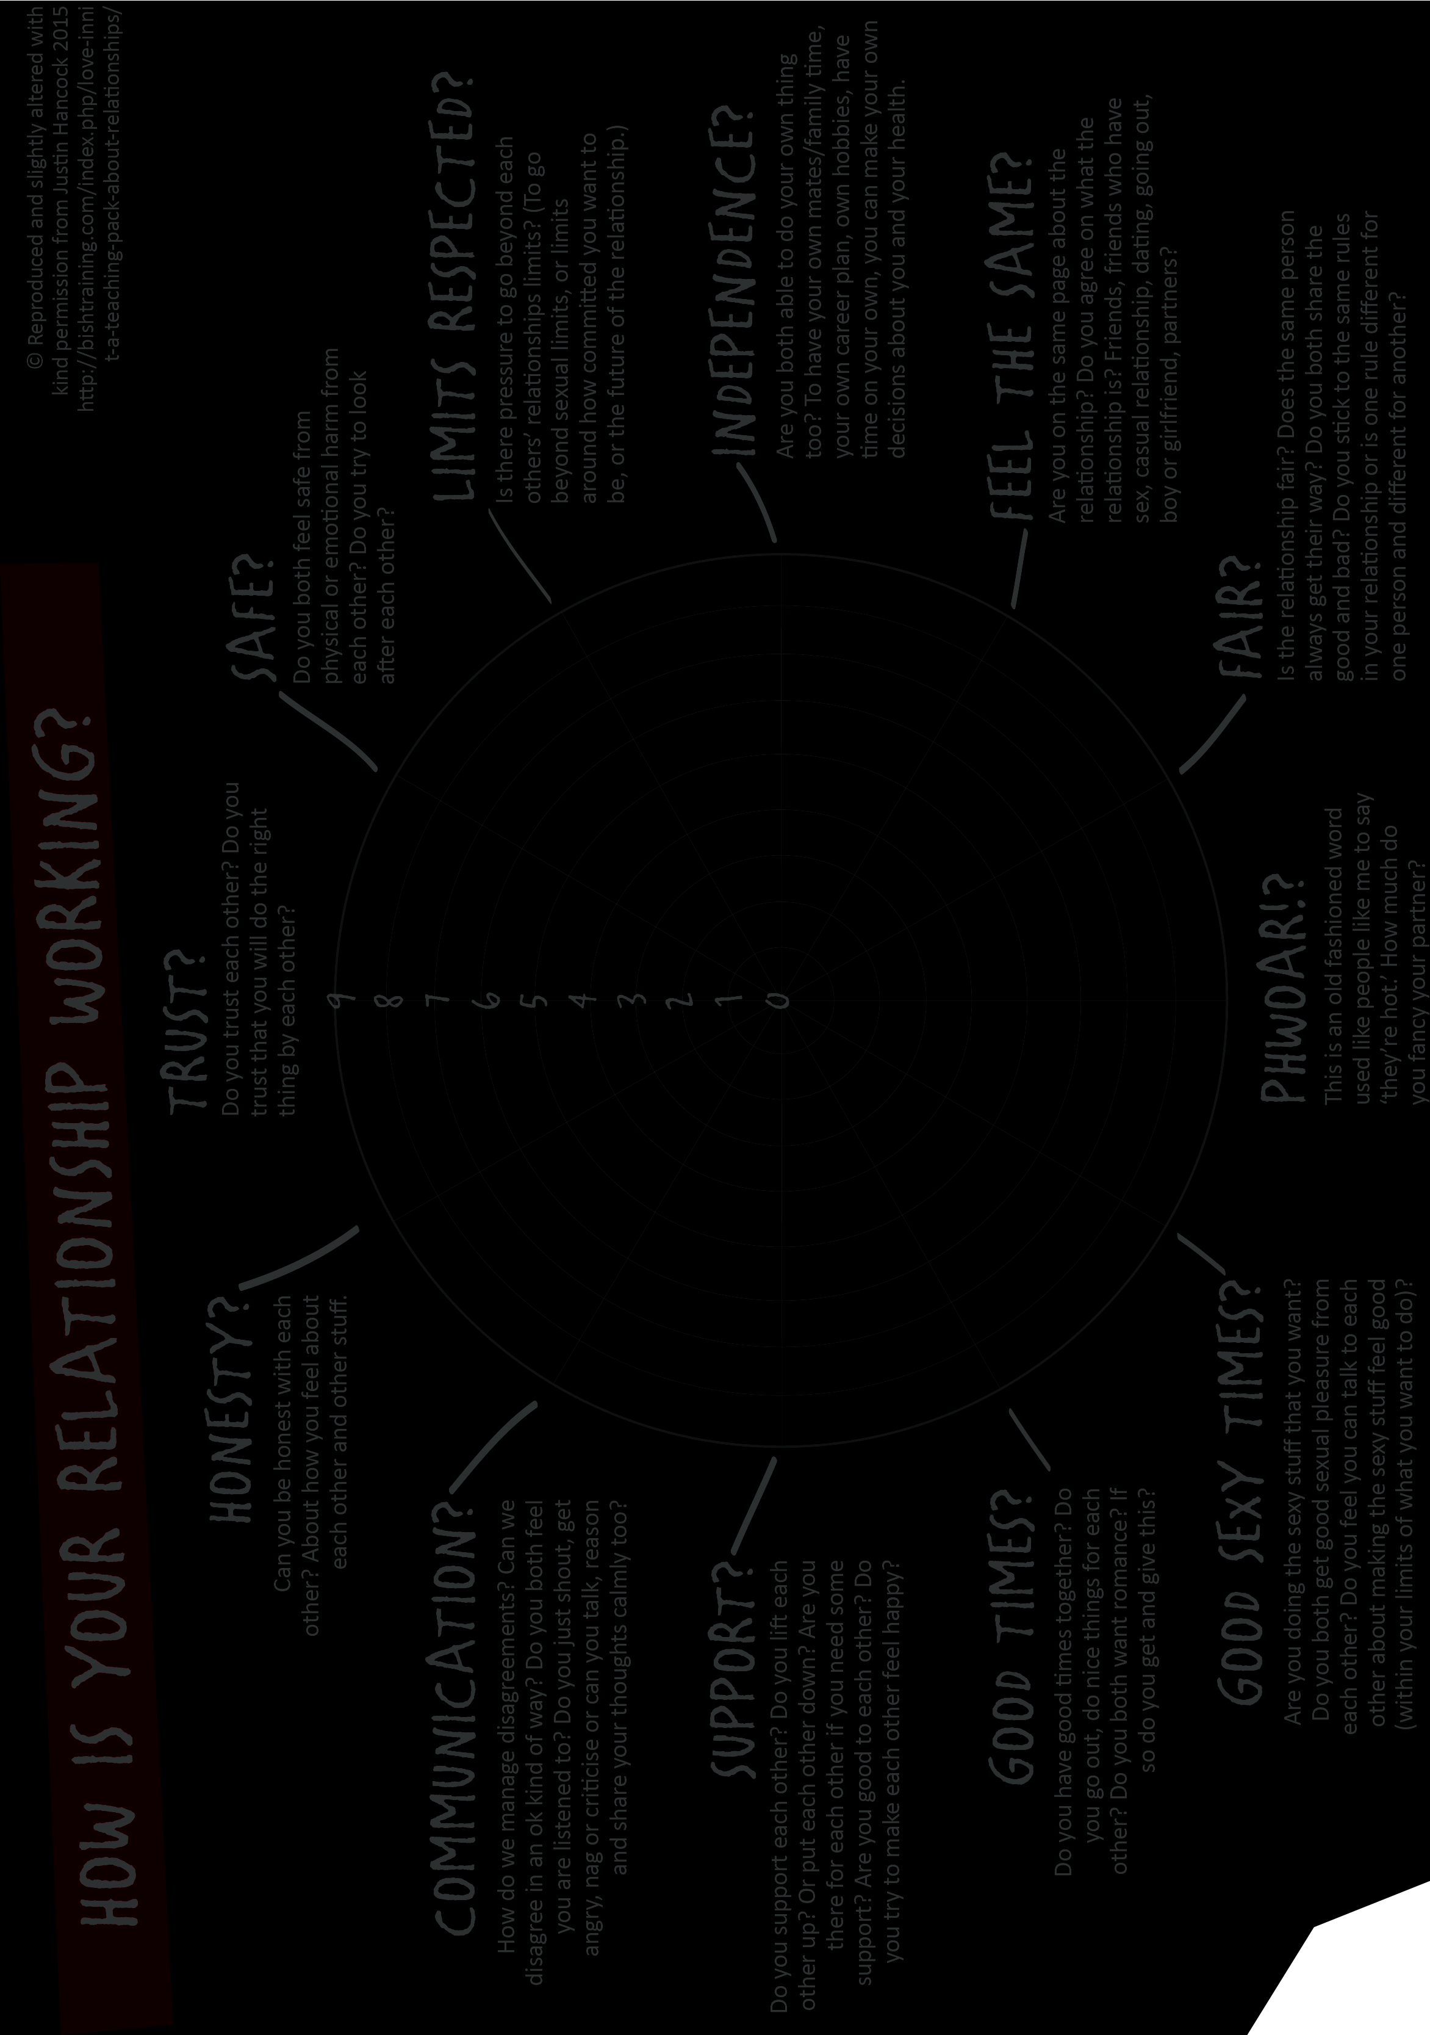

H2: RELATIONSHIP CHECK-UP SCENARIOS

Scenario 1 – Hannah, Andrew and Megan Hannah’s best friend, Megan, has been going out with Andrew. Hannah thinks Megan is obsessed about Andrew. While Hannah and Megan were hanging out watching movies together, Megan kept looking at her phone. Megan knew Andrew was hanging out with his friends and she was upset Andrew hadn’t texted her once all night and it was already 9:00 pm. Megan wanted to text Andrew and ask why he hadn’t texted her. In your opinion, how does Megan and Andrew’s relationship score on the graph? • Give them a score from 0-9 for each element. • Which elements could they work on?

Scenario 2 – Justine and Maddie Justine really likes Maddie. At first Justine thought it was cool that Maddie wanted to spend lots of time with her. She is always waiting at her locker every morning and when she gets out of class. Lately she started showing up at her soccer practice and waits for practice to end so they can walk home together. Maddie always lets her choose the movies that they go to and she’ll watch her play online games for hours. What should Justine do? In your opinion, how does Justine and Maddie’s relationship score on the graph? • Give them a score from 0-9 for each element. • Which elements could they work on? • Should they break up? • Could using the ethics framework help to figure out what’s best? 9

Scenario 3 –Jacob and Dean Jacob and Dean have been hanging out together lately, after school and some times on weekends. One day, while they were alone together, Dean put his head on Jacob’s shoulder. Then he put his arm around him and there was a lot of body contact. A week later when Jacob was flirt texting with him, Dean told him that he couldn’t “reciprocate” his feelings! Dean ignored Jacob for the next week. Then he started texting him again with flirty texts. Jacob doesn’t know what to do. In your opinion, how does Jacob and Dean’s relationship score on the

H3: HOW TO HELP A FRIEND.

It can be pretty full-on when someone tells you they’ve experienced an abusive relationship. You’ll probably have feelings of your own to deal with, and might not think there’s much you can do to help. The good news is that your friend trusts you enough to talk about their experience, and there are heaps of things you can do to support them.

Here are some of the most important ones:

Listen Hear what they say and try not to interrupt. Let them talk at their own pace. Show them you are listening by making eye contact and nodding. Don’t worry if they stop talking for a while – silences are OK.

Believe Try not to overdo the questions, as this can make it seem like you doubt their story. It’s important that your friend sees you’re on their side and that you support them.

Validate Tell your friend that what they’re feeling is right. Let them know you think their feelings are real and normal, by repeating the feeling word they’ve used (e.g. ‘it’s OK that you feel scared’). Acknowledge that you have feelings about it too, but try to keep the focus on your friend.

Shh It’s important that your friend trusts you and feels like they’re in control of the story. If you think someone else needs to know (e.g. a teacher or another trusted adult), tell your friend first. You can think together about who can be trusted, but don’t tell them until your friend is OK with it.

No blame In our society, it’s common for victims to be blamed for their experience of violence. Try to avoid questions such as ‘Why did you go there?’ and ‘Why did you go out with him?’ because they might make your friend think they’re responsible for what happened. 12

Ask If you feel a bit helpless, ask your friend what sort of help they’d like from you. They’re not expecting you to solve the problem, and you’ve already done heaps just by listening. Asking will also help your friend think about what to do next.

Get help Talk with your friend about what would help stop the violence (if it is still happening), or what they feel they want. Encourage your friend to tell a trusted adult who can do something about it, such as a relative, a teacher or a school counsellor.

Helplines and Websites
The links below may provide additional information about the laws around sexual abuse and harassment and advice about where to go for help:

For someone to talk to or more information about coping with life, love, relationships, breaking up OR abusive relationships: http://lovegoodbadugly.com is a great website for young women to check up on their relationship health as well learn more about abusive relationships and where to get help.

Sex, Love and Other Stuff - Respectful relationships for young men Sex, Love and Other Stuff is a booklet developed for young men, with young men, that talks about sex, relationships, power and respect. It can be downloaded here: http://www.dvrcv.org.au/sites/default/files/ SexLoveAndOtherStuff-DVRCV.pdf

The Line Discussion and advice on handling relationship issues, and what’s crossing the line when it comes to abusive behaviours. Call the 24 hour national relationship helpline Ph. 1800 RESPECT (1800 737 732) to talk to an experienced counsellor. http://www.theline.gov.au/

Look up: Centre Against Sexual Assault in your state or area. They have different web addresses in different areas. You can phone them, get support and advice if you or someone you know has been sexually assaulted, or get great online advice.

Reach Out Information and stories on a range of issues including sex, relationships, safety and violence, and sexuality. www.reachout.com

Life Line Confidential telephone counselling. Ph. 131 114 (cost of a local call)

Police or Ambulance Ph. 000 in an emergency for police or ambulance

For legal information: www.lawstuff.org.au/vic_law/topics/ www.legalaid.vic.gov.au/get-legal-services-and- advice Information adapted from Building Respectful Relationships: Stepping out against gender-based violence, Department of Education and Early Childhood Development, 2014.

